APPLICATION BUILDING

RUN THE APP

|  |  |
| --- | --- |
| Team ID | PNT2022TMID48753 |
| Project Title | DemandEst- AI Powered Food Demand Forecaster |

TEAM LEADER:

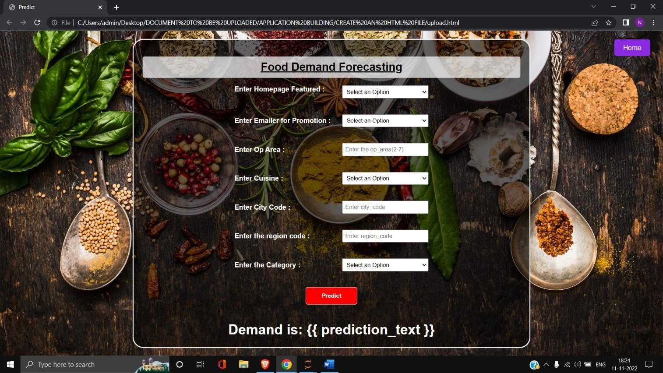

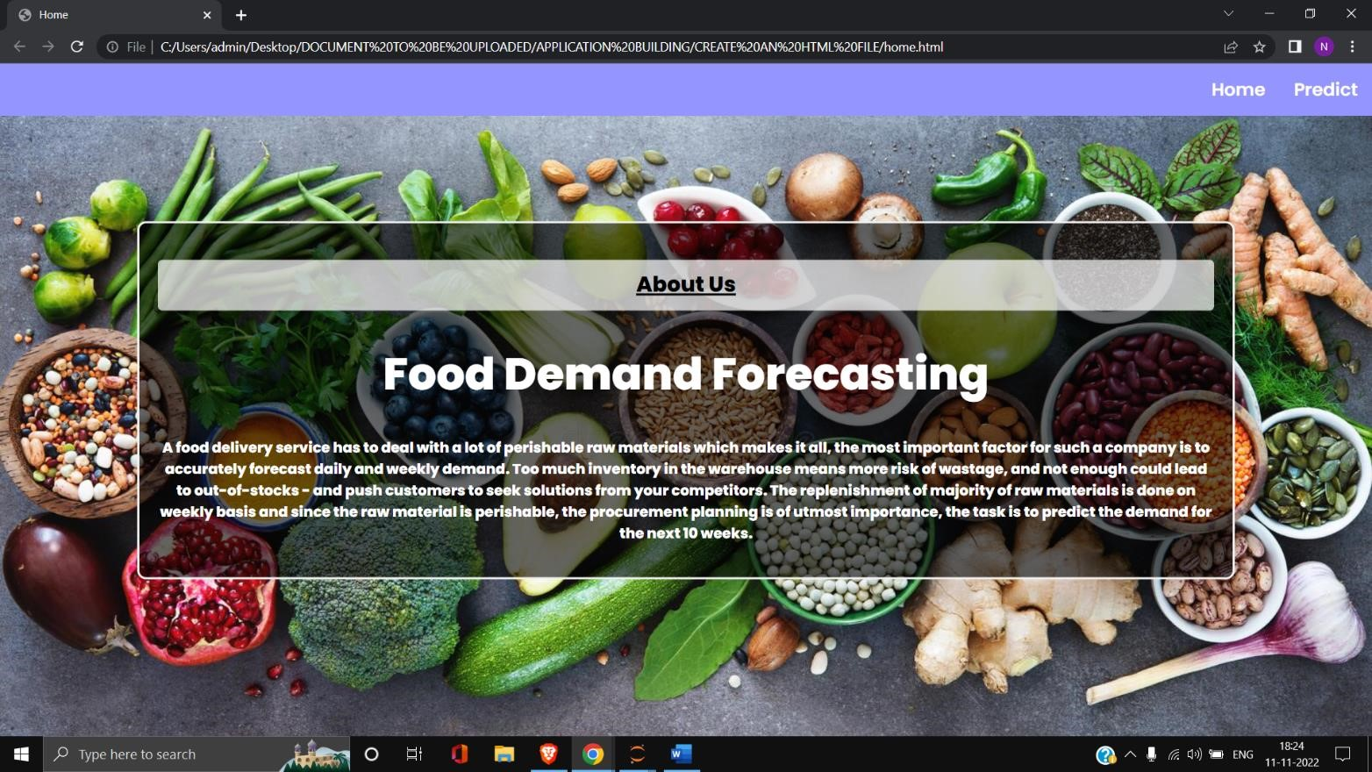

TEAM MEMBER 1:

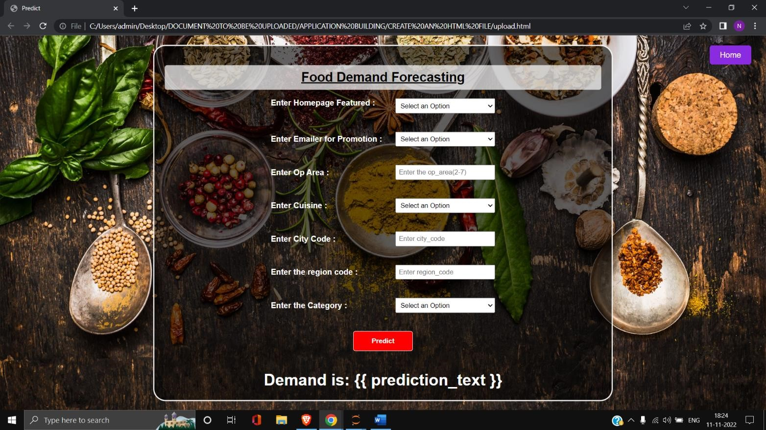



TEAM MEMBER 2:





TEAM MEMBER 3:



